**University of Michigan – Dearborn**

**CIS 150 – Computer Science 1**

**Lab# 9**

**Professor Bacha**

Demetrius Johnson

[meech@umich.edu](mailto:meech@umich.edu)

March 18, 2020

**Table Content**

Contents

Question 1 3

Test Cases 3

Source Code – see LAB9Q1.cpp 3

Screenshots 3

Question 2 6

Test Cases 6

Source Code – see LAB9Q2.cpp 6

Screenshots 6

# Question 1

## Test Cases

|  |  |  |  |  |  |
| --- | --- | --- | --- | --- | --- |
| Test # | Valid / Invalid Data | Description of test | Input Value | Actual Output | Test Pass / Fail |
| 1 | valid | Test if searched value will return a true or false properly in 2D array | See screenshot | See screenshot | pass |
| 2 | valid | Test if searched value will return a true or false properly in 2D array | See screenshot | See screenshot | pass |
| 3 | valid | . Test if 2D array sum and average found accurately | See screenshot | See screenshot | pass |
| 4 | valid | . Test if 2D array sum and average found accurately | See screenshot | See screenshot | pass |

## Source Code – see LAB9Q1.cpp

## Screenshots

TEST 1

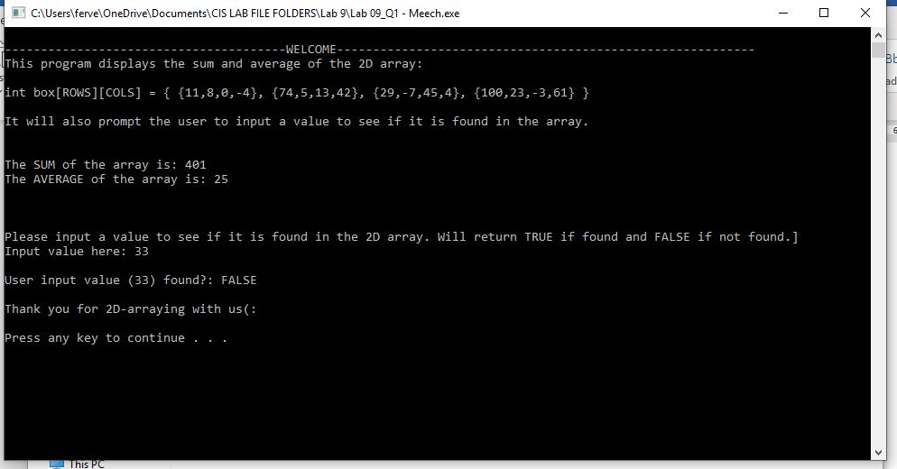

TEST 2

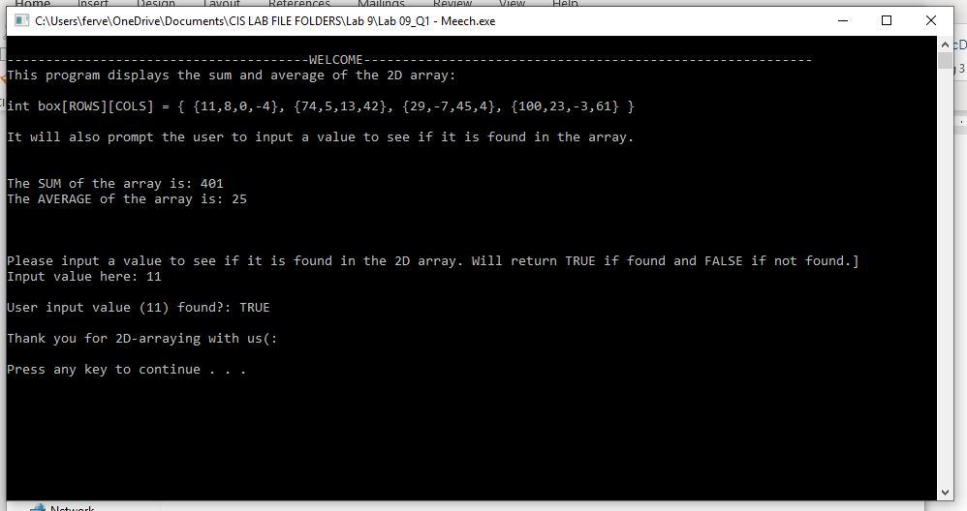

TEST 3

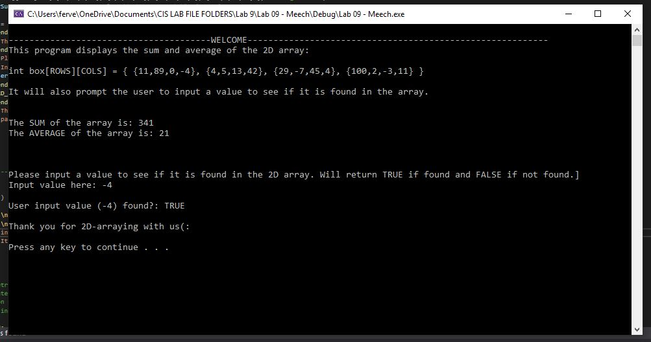

TEST 4

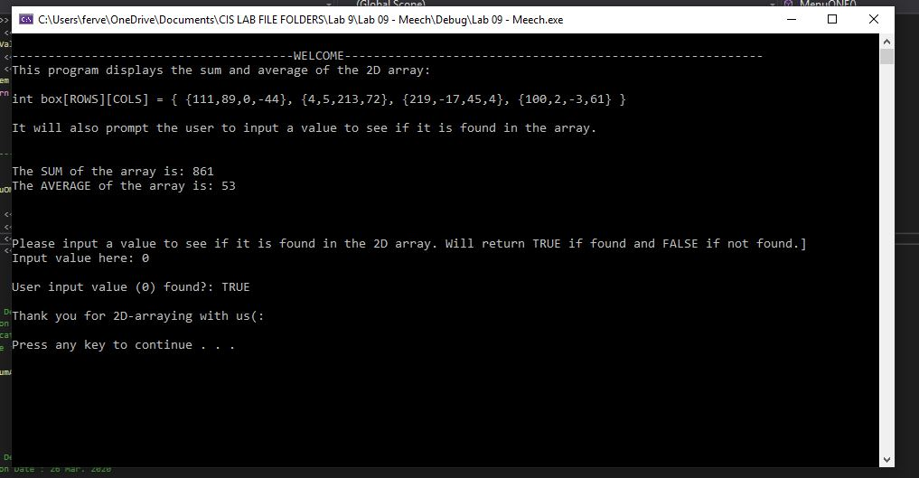

# Question 2

## Test Cases

|  |  |  |  |  |  |
| --- | --- | --- | --- | --- | --- |
| Test # | Valid / Invalid Data | Description of test | Input Value | Actual Output | Test Pass / Fail |
| 1 | valid | See if a different number of students from file can be processed effectively | 10 students file | See screenshot | pass |
| 2 | valid | See if a different number of students from file can be processed effectively | 7 students file | See screenshot | pass |
| 3 | valid | See if a different number of students from file can be processed effectively | 6 students file | See screenshot | pass |
| 4 | valid | See if a different number of students from file can be processed effectively | 5 students file | See screenshot | pass |

## Source Code – see LAB9Q2.cpp

## Screenshots

TEST 1

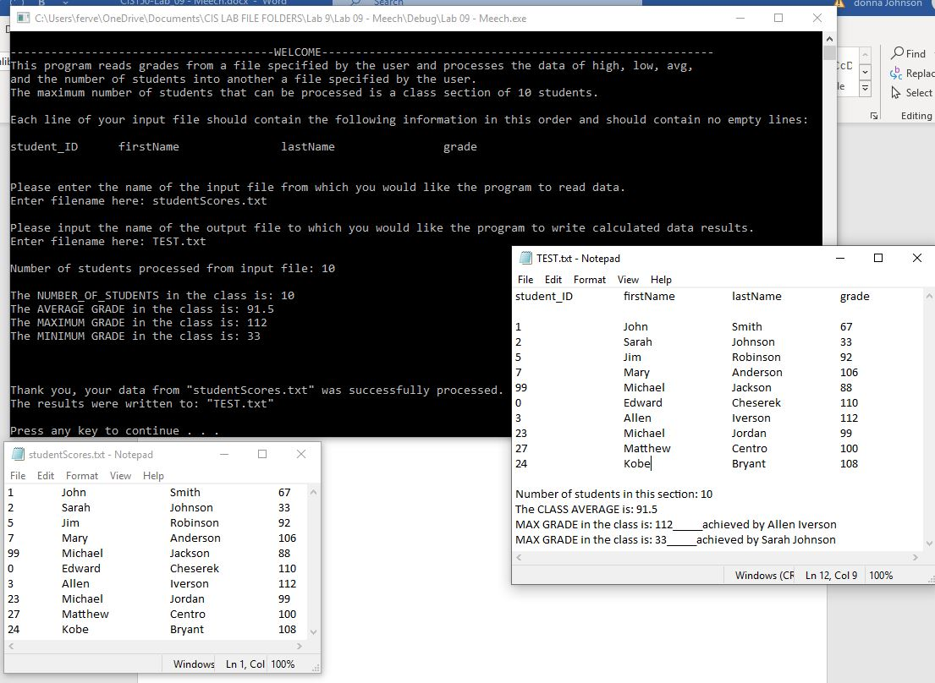

TEST 2

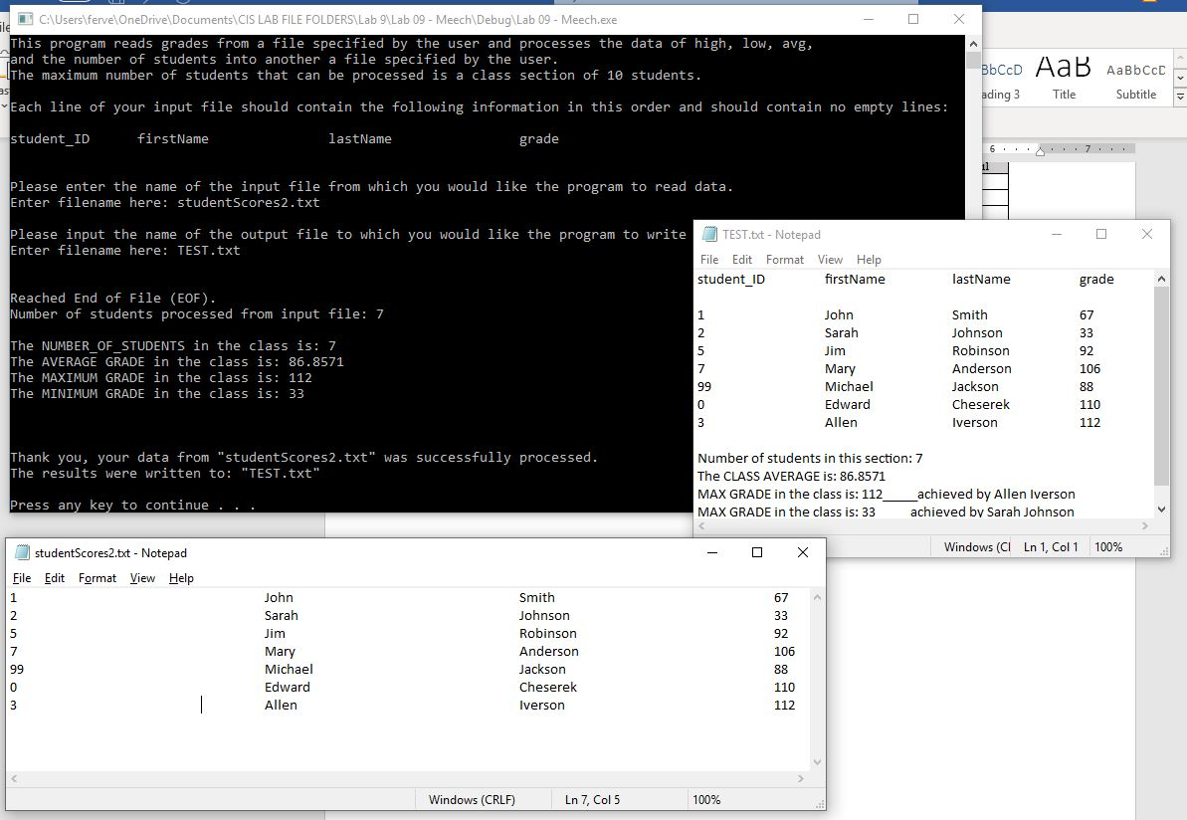

TEST 3

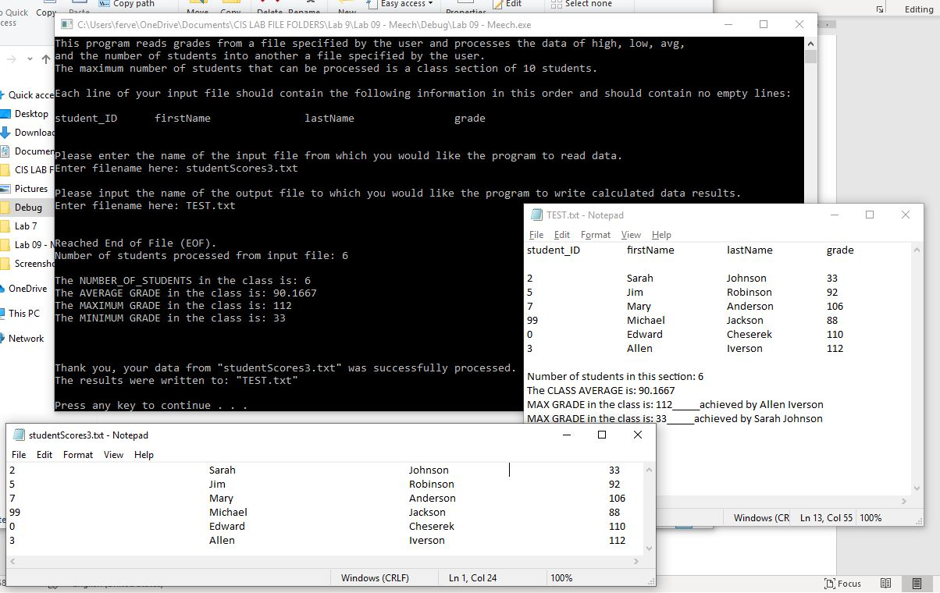

TEST 4

